# PRODUCT CREATION - (PRODUCT MODULE ASSIGNMENT)

## Using EntityEngine

Step 1 - Create a new product by entering all the required fields. Select **is Virtual Product as Y**

For Parent Product . Click on Create Product.

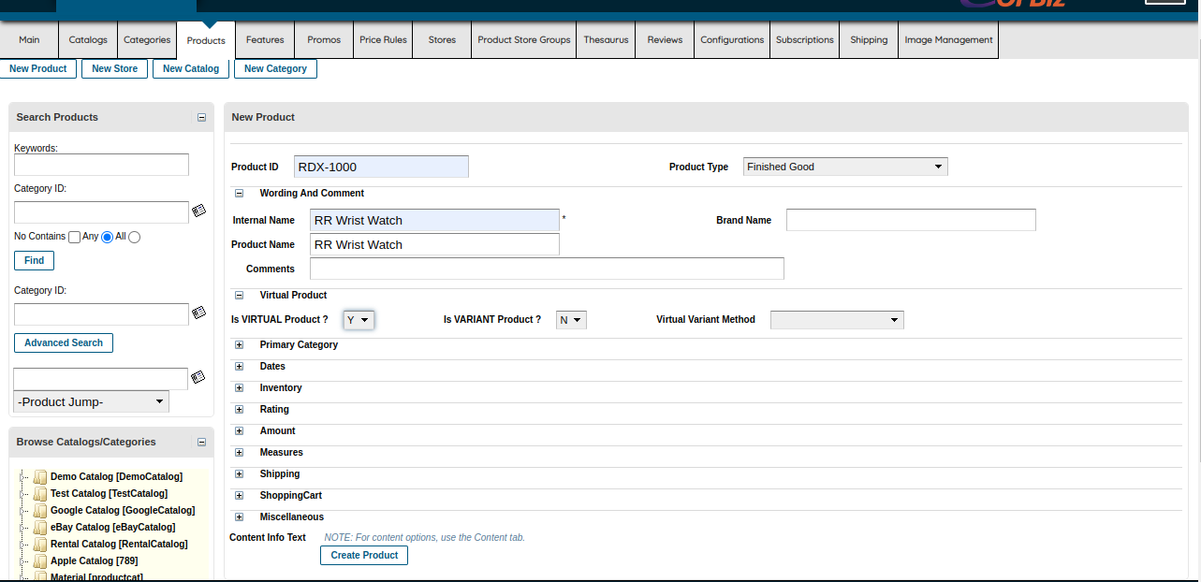

Fig 1.1

Step 2 - Create a new Product which is supposed to be a variant of the base product or parent product . **Change** the **ProductID** in order to avoid **duplicate** **Key** error.Set **isVirtualProduct** as N and **isVariantProduct** as Y , as this will be a Variant of the base product as seen in **Fig1.2**

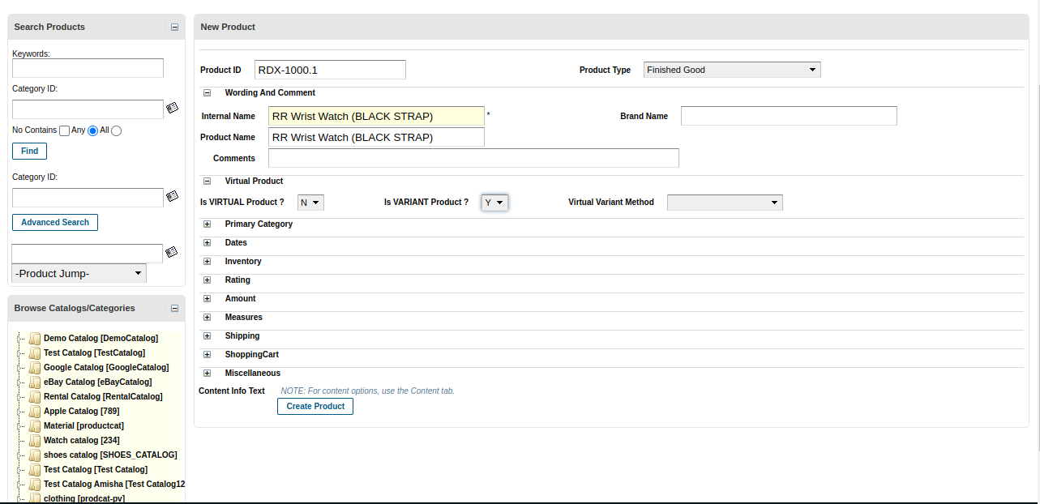

Fig1.2

Step 3 - In the entityEngine web tool , search for **productAssoc** in order to associate a variant product to a base product. In **ProductID** set the **base product ID** , and in the **ProductID to** set the **variant product id .** Set the **ProductAssocType** as **VARIANT_PRODUCT** to justify the variant product and also set the From date which is a required field.as seen in **Fig1.3**

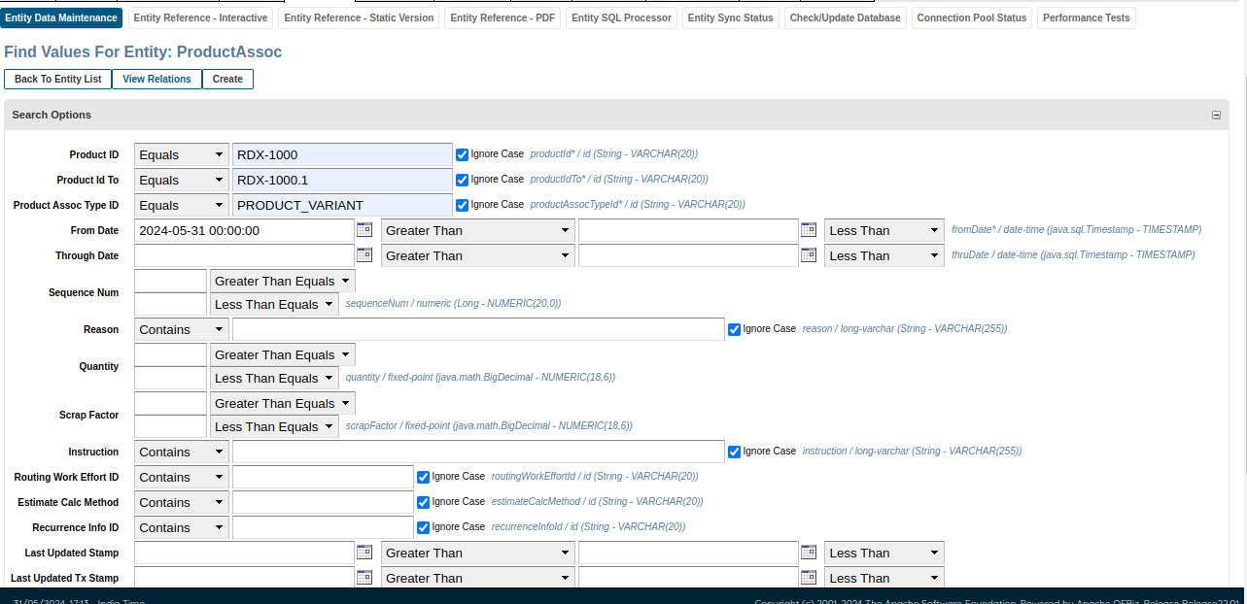

Fig1.3

Step 4 - To verify if the **Variant Product** is setted to its **Base Product** , in the **entity engine** go to **ProductAssoc** and search the product using **Parent Product ID** as seen in **Fig1.4**, here we can notice the association of our variant product with our base product

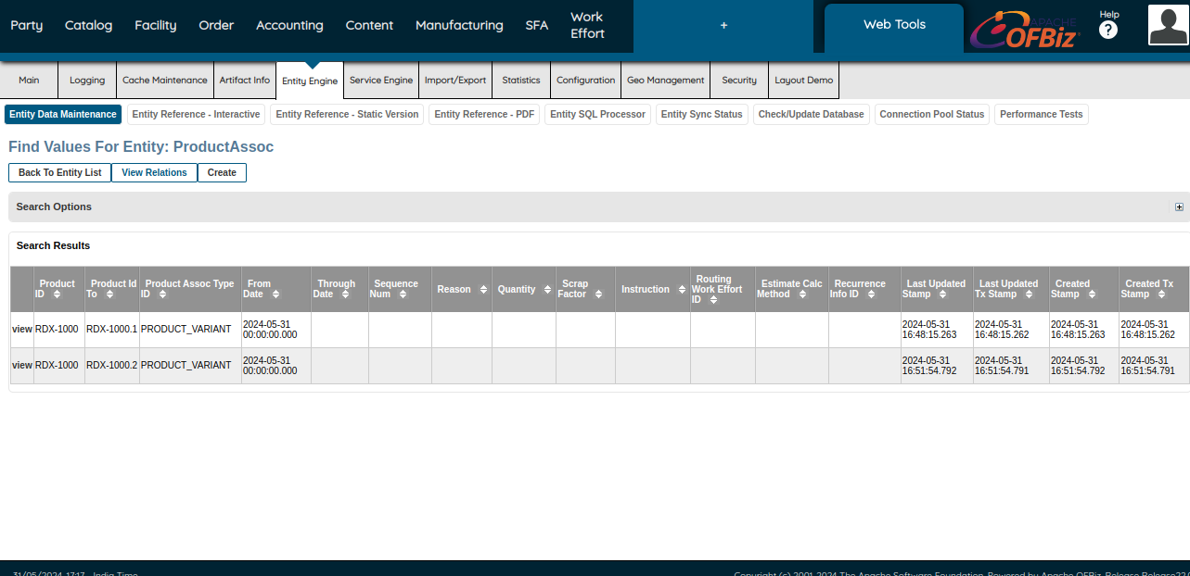

Fig1.4

## USING XML

In the **webTool -> import/export -> XML DataImport** , by this we can write XML code with **ProductAssoc fragment** to associate a **Child Product** i.e a Variant Product with its **Base Product** i.e Parent Product as seen in **Fig2.1**

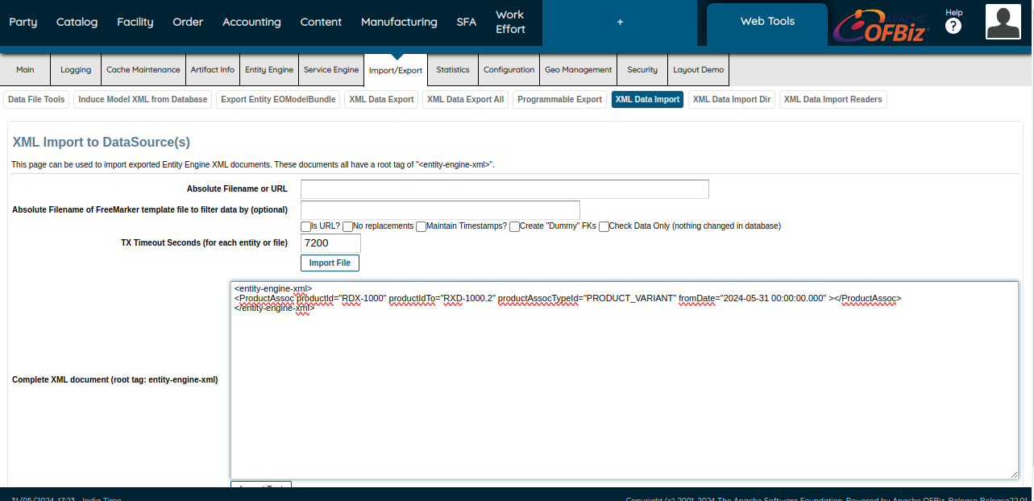

Fig2.1



Fig2.2

## Associating Product With Store

First we create a new Product Category so that we can link the product with the **productCategory**. as seen in **Fig3.1**

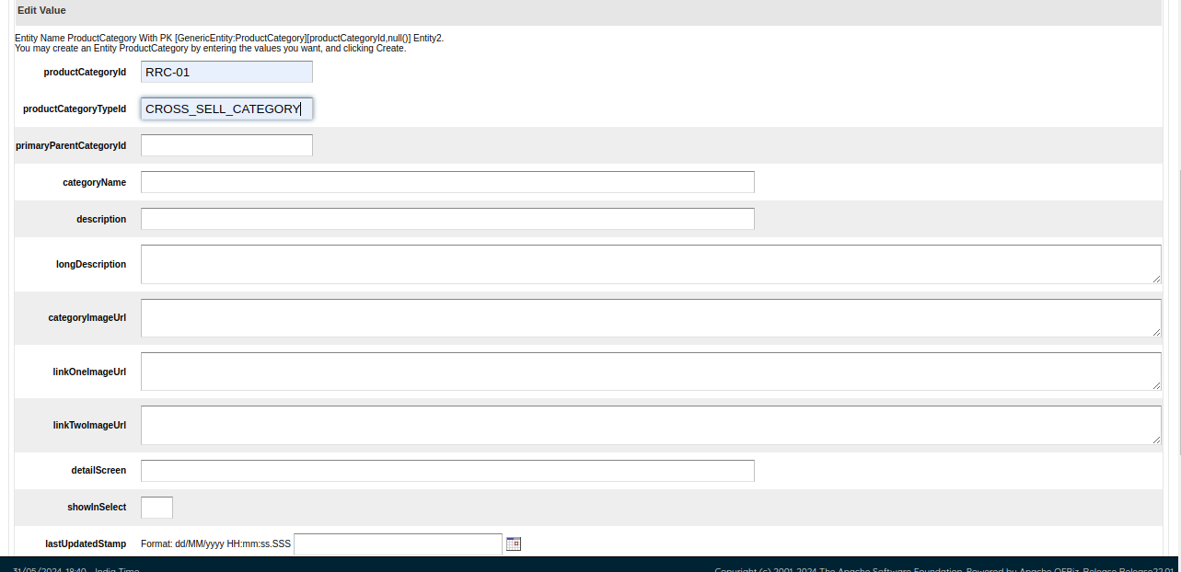

Fig3.1

In order to link the Product with product category we will use **ProductCategoryMember** which is an assoc entity as seen in **Fig3.2**

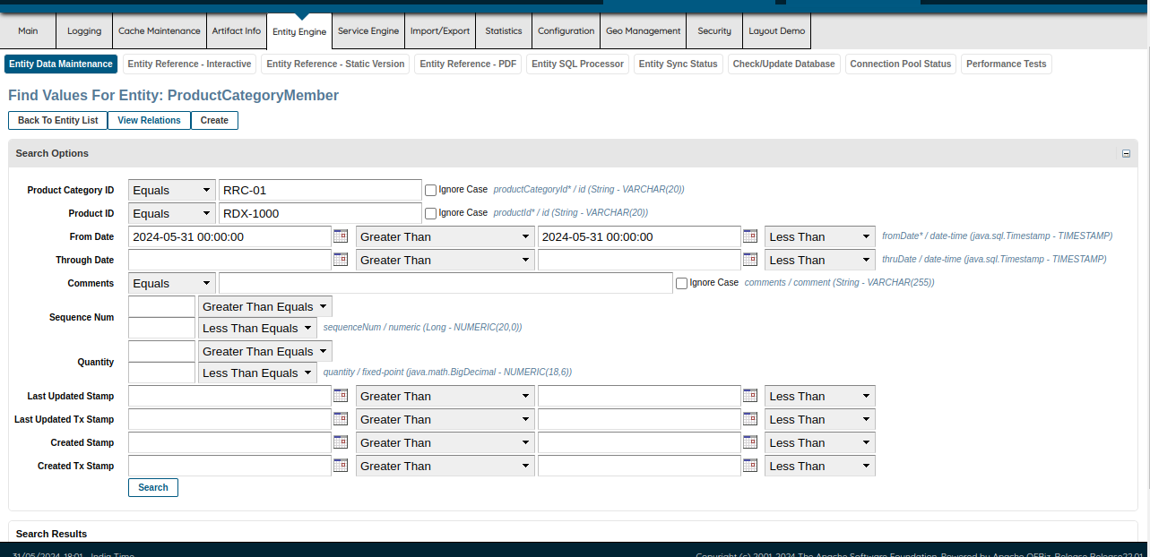

Fig3.2

Now we have to create a new product catalog for our new product.We can do that by creating a new catalog from entity engine as seen in **Fig3.3**

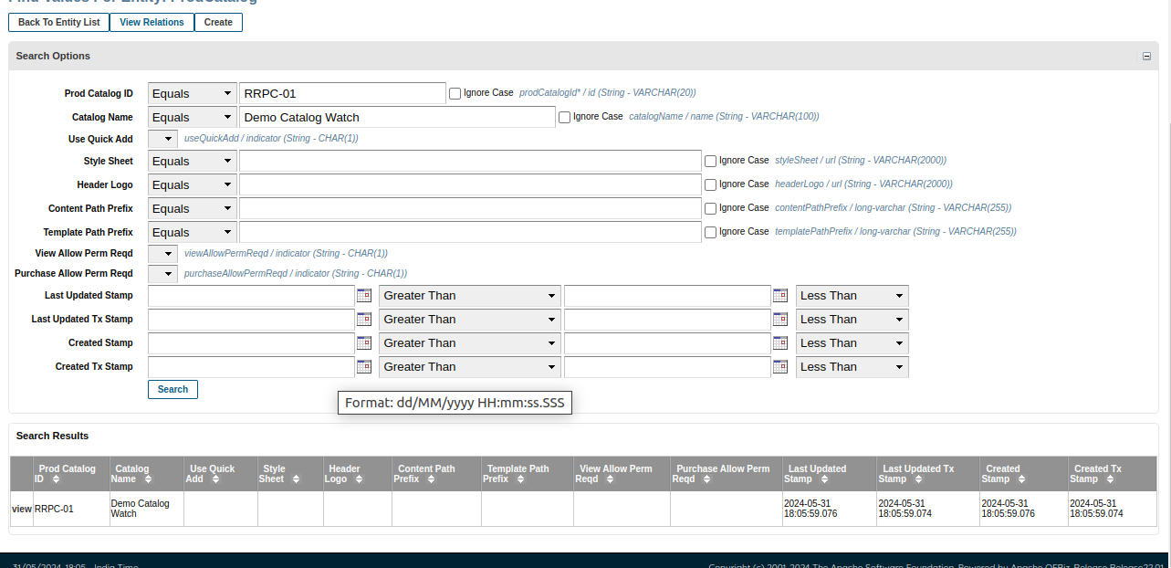

Fig3.3

Now that we have created a new product catalog , we can link product catalog and product category using **ProdCatalogCategory** which is an assoc Entity. We can link both catalog and category by added their Unique id’s in the assoc entity.as seen in **Fig3.4**

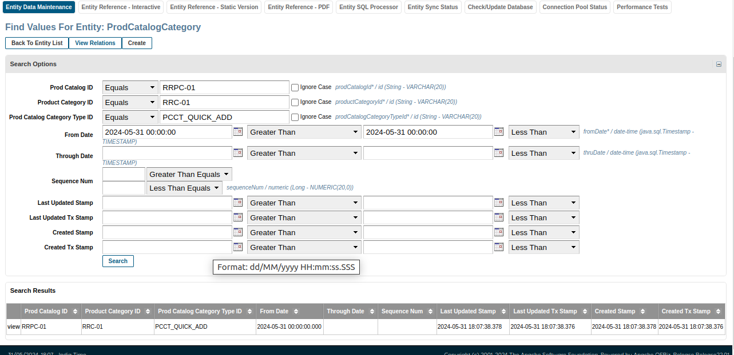

Fig3.4

Now to show our product in the store we can make a new store , by using **productStore** entity from **entityEngine**. For that we can set a unique ID to store and give it a name.as seen in **Fig3.5**

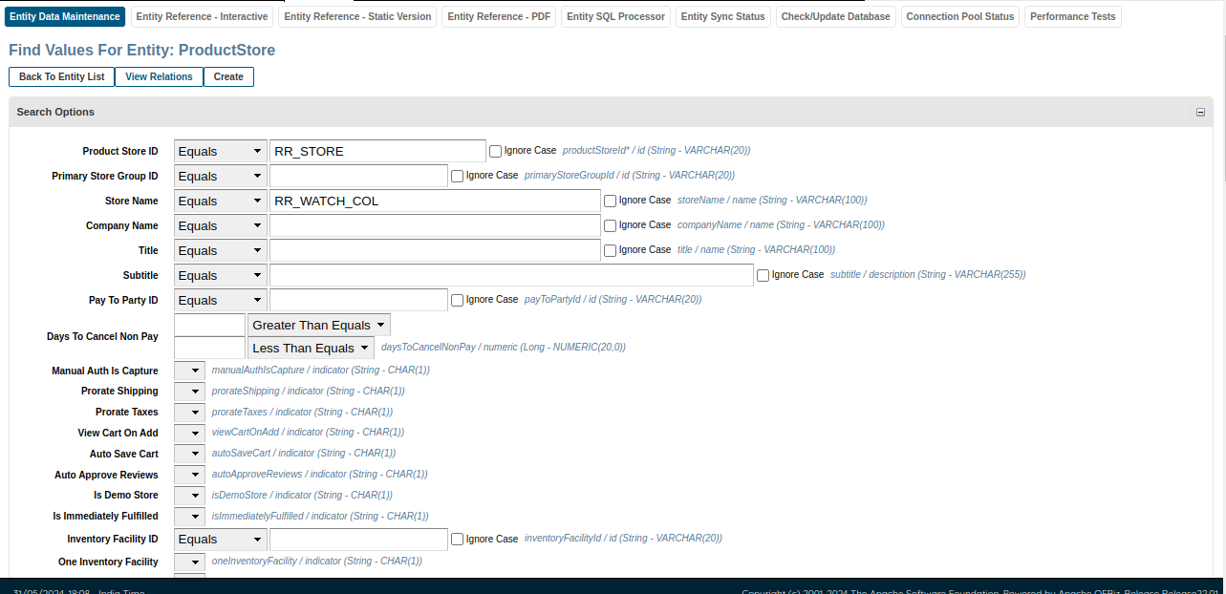

Fig3.5

In order to link product store and product catelog we will use another assoc entity that is Product store catalog , where we can enter unique id’s of both Product Store as well as Prod Catalog .

as seen in **Fig3.6**

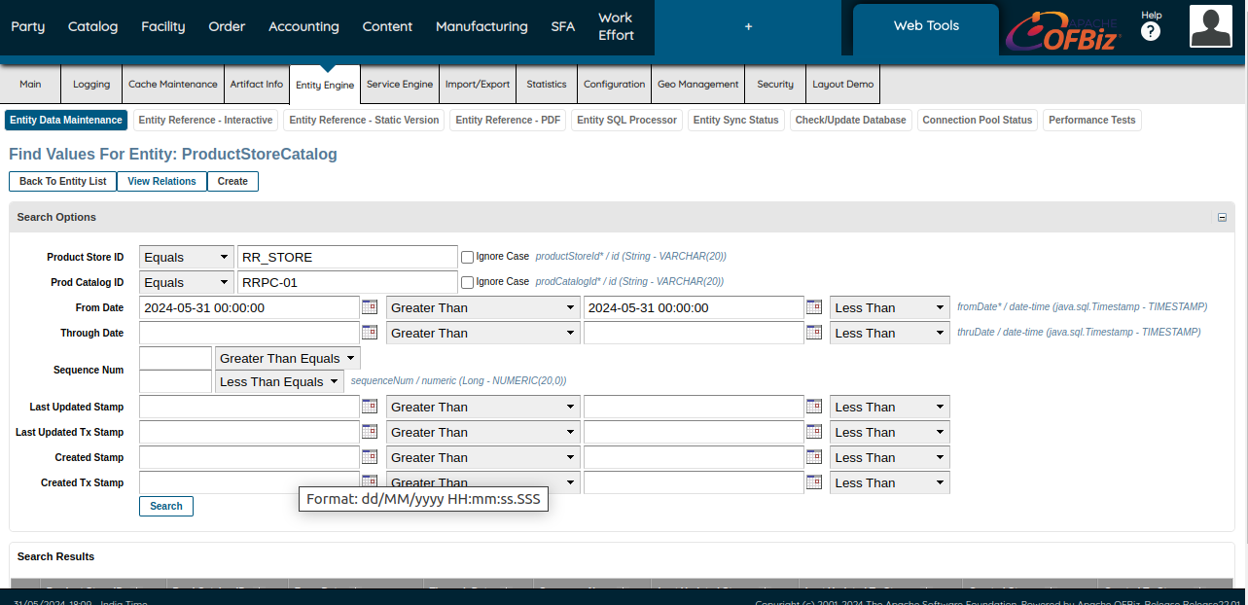

Fig3.6

Now that we have completed all the steps , we can check our product by running this query

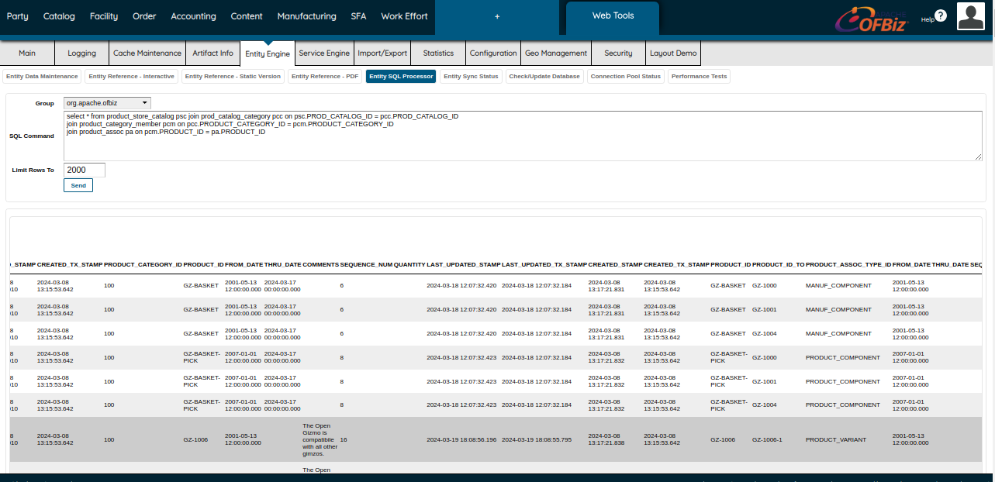

Fig3.7

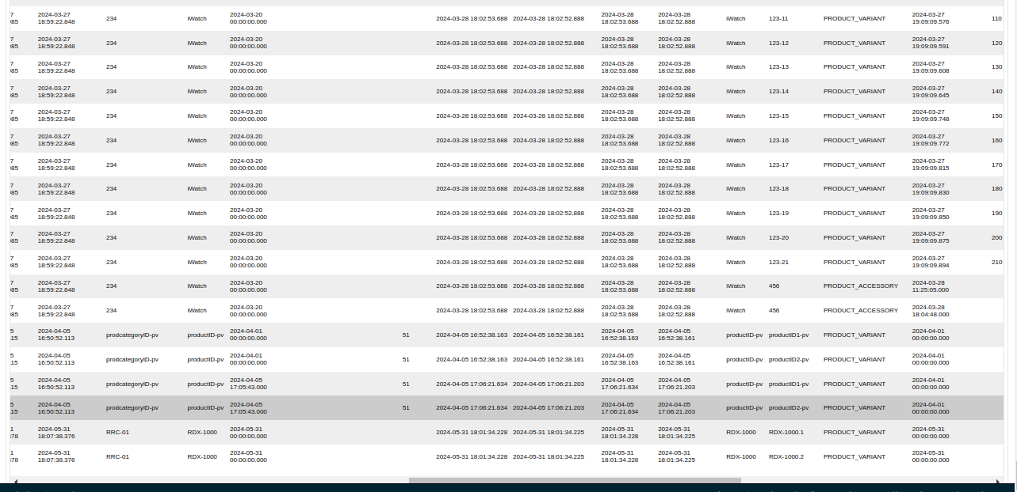

Fig3.8

Here is the result as seen in **Fig3.8**

